**Dog Salon Database Design Document**

**Version 1.0**

**Submittal Date: 09/01/2021**

|  |  |
| --- | --- |
| Version | Description |
| 1.0 | First release draft |

**Table of Contents**

**Topic Page**

**Purpose…………………………………………………………………………………………4**

**Narrative……………………………………………………………………………………….4**

**Requirements (Actors/Roles)………………………………………………………………….5**

**Entities………………………………………………………………………………………….5**

**Entities(w/ Nested Attributes)………………………………………………………………6-7**

**Business Rules…………………………………………………………………………………..8**

**ERD……………………………………………………………………………………………..9**

**EERD……………………………………………………………………………………………10**

**Purpose**

The purpose of this Database Design Document (DBDD) is to keep track of all the functions that occur with customer / supplier related manners. Tracking everything from when the customer is helped along with the dog that follows , to the service that is going to be done to the dog and which supplies were used by which employee is the goal.

**Narrative**

Dog Salon is a pet salon located in the Tampa Bay area that serves many customers every day. They pride themselves on ensuring that every dog that visits their shop leaves looking better and smelling cleaner, with a wagging tail of satisfaction. The Salon wants to design a database to track the business process described below. Dapper Dog Salon tracks their customers (dog owners). They register each customer to keep their information up to date and to have the ability to contact customers. The Salon tracks each customer’s name, address, phone number, email. The Salon also tracks each dog’s name, breed, temperament, date of birth, and age. Dogs are owned by customers. A customer can have more than one dog. A dog can be picked up by a customer or an authorized family member. Family members are registered to a customer for pickup permission which allows them to access their family’s dog(s) at the salon.

The Salon purchases products from wholesale groomer supply stores. The product information is tracked by product number and the product description such as shampoo, styling tools, bows, nail clippers, combs, and other similar items. The Salon has a list of wholesale groomer supply stores that they purchase from. The orders come directly from the supplier. They track the name, address, and phone number of the supplier. Some suppliers offer more than one item and some items come from more than one supplier. The Salon provides services that customers select for their dogs to receive. The services are tracked by type and description of service. The Salon wants to track which products are used for which service so they can be efficient in product ordering. Some services use no products, while other services may use more than one.

A product may have multiple uses for different services. They also want to track which employees provide which services to which dogs on which dates. Services offered such as washes, haircuts, hair styles, nail trimming, nail painting, and flea treatments. Customers have the option to arrange a set of preferred services for their dog that are automatically performed whenever a dog is dropped off. The Salon maintains simple employee information: name, address, and phone number. An employee may perform one or more services for a dog.

**Requirements (Actors and Roles)**

Customer: The person who comes in to drop their dog off at the dog salon.

Family Member: Someone who has authorization under the customer to pick up the dog from the salon.

Dog: A dog must have an owner/customer there cannot be a dog without an owner

Salon : The place customers drop their dog(s) off . This is also where suppliers drop off products/merchandise for the store.

Suppliers : Brings products in for the store.

Employee : The person that is servicing one or more dogs , which service they are doing and which products their going to use .

Service : Which service is going to be done on a dog .

Products : Product that is going to be used on a dog.

**Entities**

* **Customer**
* **Family Member**
* **Dog**
* **Salon**
* **Suppliers**
* **Employee**
* **Service**
* **Products**

**Entities w/Nested Attributes**

* **Customer**
  + CustomerID
  + Name
  + Address
  + Phone Number
  + Email
* **Dog**
* DogID
* Name
* Breed
* Temperament
* Date of Birth (DOB)
* Age
* **Family Member**
  + CustomerID
  + DogID
* **Salon**
  + SupplierID
  + ProductID
* **Supplier**
  + SupplierID
  + Name
  + Address
  + Phone Number
* **Employee**
  + EmployeeID
  + Name
  + Address
  + Phone Number
  + Product
  + Service
  + DogID
* **Service**
  + ServiceID
  + ServiceName
* **Products**
  + ProductID
  + ProductName

**Business Rules** :

Customer : Must have 1 dog to be registered in the system. Customers can also have more than 1 dog.

Dog : Dog can only be registered to one Customer, but the dog can have multiple authorized personnel for pick up under said customer.

Supplier(s): The ones that provide Products / Material to operate the business.

Employee(s): Person that is servicing the dog including products used and date serviced.

Family Member(s) : Authorized people that are able to pick up a dog under the primary customer.



ERD MODEL

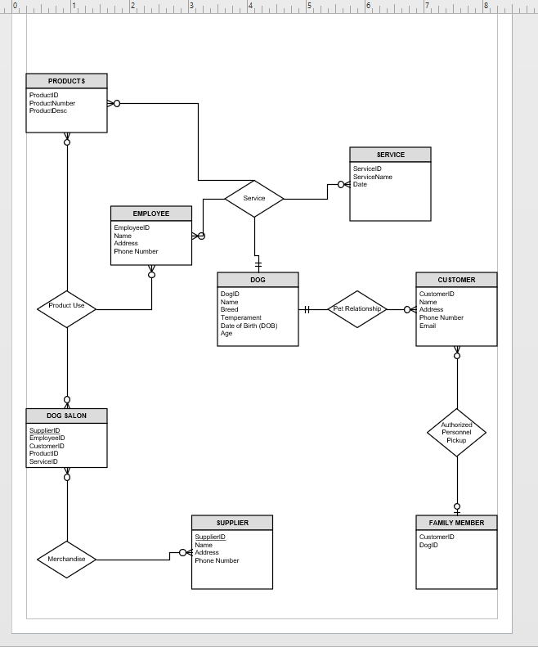EERD MODEL